Abstract template for acpm 2027
Author1, author 2, author3, and author4

¹Institute for Aerosol Science & Technology, Department of Chemistry, University of Mumbai, Fort, Mumbai 400 001, India
²Department of Chemistry, University of Jaipur – 302 004, India.

E-mail of corresponding author (Font: Times New Roman, 11 pt, Italics; Line space: 12pt; Left alignment)
Keywords: WWWWWWW, XXXXXX, YYYY, ZZZZZZ
Abstract

The abstracts produced should be camera-ready and up to TWO pages long on separate sheets of paper. On the first page of the abstract, start typing text here (about 7cm from the top of the typing area). Text on the next pages can start at the top of the typing area (where the title is on this page). All parts of the abstract should fit within a box measuring 240 mm high by 165 mm wide. There should be a top margin of 29 mm, a left margin of 23 mm. Times New Roman is preferred, and use an 11pt font size. The title should be in bold capitals, the authors’ names should be in capitals, and the addresses of the authors should be in lower case. All these should be centered.

The abstracts should be submitted in Word format.

Graph / Table of Contents: Graph / Table of Contents should use only ONE picture to give the reader a quick visual impression of the essence of the manuscript without providing specific results.

INTRODUCTION

The abstracts produced should be camera-ready and up to TWO pages long on separate sheets of paper. On the first page of the abstract, start typing text here (about 7cm from the top of the typing area). Text on the next pages can start at the top of the typing area (where the title is on this page). All parts of the abstract should fit within a box measuring 240 mm high by 165 mm wide. There should be a top margin of 29 mm, a left margin of 23 mm. Times New Roman font is preferred, and you should use a character size of 11pt. The title should be in bold capitals, the authors’ names should be in capitals, and the addresses of the authors should be in lower case. All these should be centered.

METHODS

You can include up to four keywords or key phrases, as shown. You should, if possible, use the categories shown on the abstract classification form. For example, if you wish to indicate that your work is related to aerosol-cloud interactions, then use this form of words (as they appear on the classification form) instead of some permutation such as cloud-aerosol interactions. This will allow us to construct a keyword index to connect related papers.

RESULTS & DISCUSSIONS

Pages should not be numbered. You may arrange your text under headings, in capitals and centred. Figures and Tables may be included in the abstracts, but please make sure that they all have a caption, and that they are numbered consecutively using Arabic numerals.

Month | Measured density (g/cm3) | Predicted density (g/cm3)
January | 0.4 | 121
February | 0.7 | 379
March | 0.9 | 845
May | 1.3 | 1030
June | 2.4 | 15280

Table 1. Comparison between theoretical predictions and experimental measurements.

The font used in captions can be smaller than used elsewhere, but be advised that anything smaller than 10pt may become illegible when reduced (slightly) for printing. Make sure that the caption fully describes all the features in the Figure or Table. Vertical lines in tables should be avoided.
References should be made in the style (Bakshi, 1975), or (Alexander and Nathan, 1986; Finn et al., 1998) or simply refer to Finn et al. (1998). Examples of journal articles, Conference Proceedings and book. references are shown overleaf
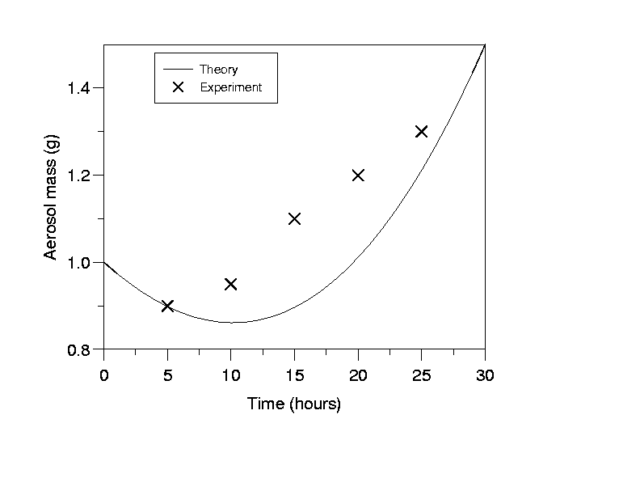
Figure 1. This is the sort of Figure which illustrates good agreement between theory and experiment.

CONCLUSIONS
Point out the findings of the work in the conclusion section. Conclusions should be precise and to the point.

ACKNOWLEDGEMENTS
This work was supported by the Board of Research in Nuclear Science under grant A1/001.

REFERENCES
Alexander, F.R. and J.O. Nathan (1986). An Introduction to Ultrasonic Nebulisation, (Cambridge University Press, Cambridge, U.K.).

